API Review for DSA 8600 LV PnP Part II

1. Store Waveform to Reference Channel  
   For the below parameter, can we use Array of Rings instead of Array of Strings?  
    - Waveform Source  
    - Timebase Source  
    - Waveform Save Channel  
   btw, please use plural forms (e.g. Sources) to indicate this is an array input.
2. Save Load Clock Recovery Settings.vi  
   Please remove the ‘_’ in the Ring items and descriptions.  
   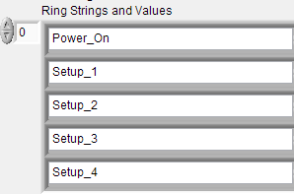
3. Configure Acquisition Average.vi  
   Number of Waveform Acquisitions -> rename to -> Average Number.
4. Configure Acquisition Stopafter.vi  
    a. Please move the key parameter: **Enable Conditional Stop** to the first position  
    b. Please do not mention SCPI command in the descriptions, instead mention the control name here.   
   Note: Please check ALL APIs description for this issue.   
   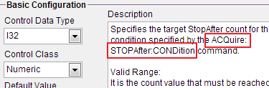
5. Configure Acquisition Mode.vi  
   Please do not use the word “Mode” in API name, because it is ambiguous. What about “Configure Acquisition Type” ?
6. Configure Compensate.vi  
   a. Please support the following missing commands :  
   COMPensate:CH<x>  
   COMPensate:MAInframe  
   COMPensate:TEMPerature:CH<x>?  
   COMPensate:TEMPerature:MAInframe?  
   b. Please add the following Note to the DARKLEV control  
   ***CAUTION.*** *Before sending this command, disconnect or disable all signals and  
   probes from all sampling input channels. Ensure that all electrical inputs are  
   terminated to 50 Ω and all optical module inputs have optical signals disabled  
   or dust covers installed before continuing. For best results, ensure that the  
   mainframe compensation is valid and leave trigger sources for the selected  
   channel connected and active.*c. Rename “Configure Compensate” to “Run Compensate”, use a ring control as a operation selector for: All Modules, Optical Dark Level, Optical Gain, Mainframe DC, Optical DC. And move this API to action/status folder or Utility folder.d. Place “Channel” on the top left position  
   e. Wave Length -> rename -> Wavelength
7. Configure TDR Step Channel  
   a. Rename control: Deskew Time to “Deskew”
8. I am thinking that we shall probably create a separate folder for Clock Recovery APIs, what do you think?
9. Configure Clock Recovery Equalizer.vi  
   a. Equalizer Value control: Is the description correct?  
   b. Equalizer Value control: please add “Default Value” in the description  
   Note: please add this section for all controls in the driver  
   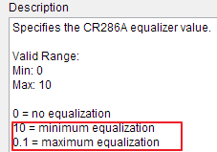
10. Configure Clock Recovery Value.vi  
    Fix the control name: “User Definued CLKRec Value”
11. Configure Measurement Reference (AOP).vi  
    What is AOP?
12. Configure Timebase.vi  
    Units control: please use full words for the ring items names  
    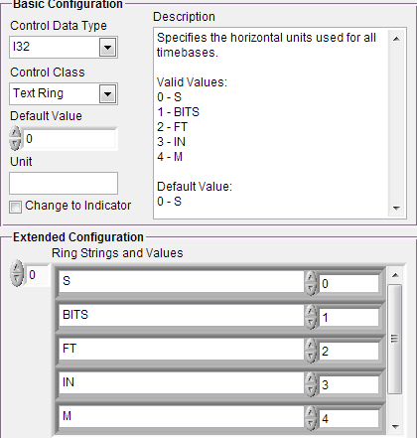
13. Configure Triger Source (Clock Sources).vi  
    Please refine the ring item name of Trigger Source control.
14. For the VI name has parenthesis, add a whitespace between character and ‘(’
15. Configure Trigger Pattern Sync.vi  
    a. Why there are two Data Rate?  
    b. Shall we place Enable control in the top side of this VI?  
    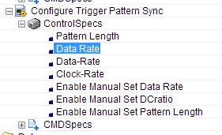
16. Utility >> ClockRecovery   
    Two VI in this folder do not have descriptions.